Week 10 Documentation
BIT/2024/73820-Julia Aywa

Comprehensive Application Development, Integration and Testing
All Screens and app files are successfully wired together to deliver a working application, Shredded Squad that has 6 screens where records are stored locally on the SQL.
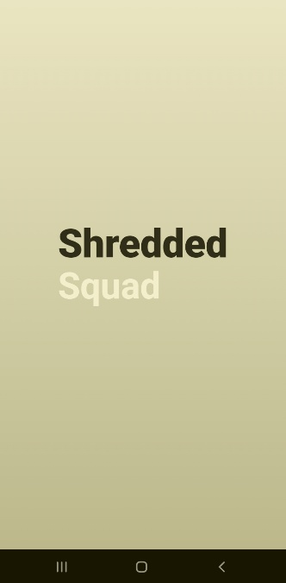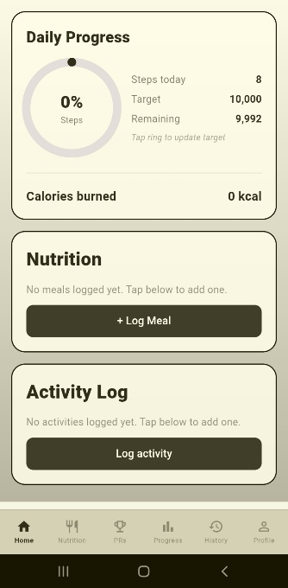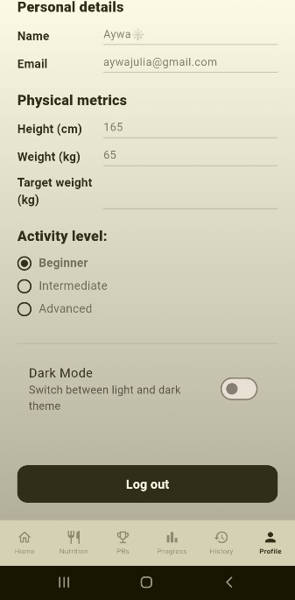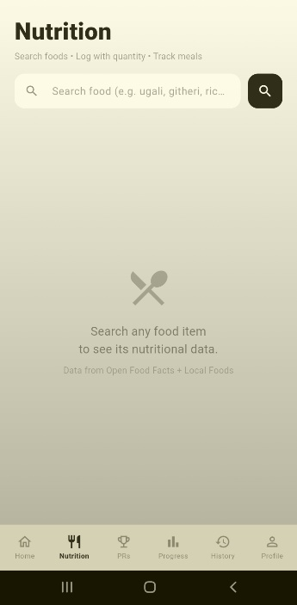

ERROR IDENTIFICATION & DEBUGGING
- Slow loading
Screen loading was slow causing the app to lag due to inefficient codes.
Solution: Wrapped the Dashboard screen tabs so they are kept alive when switching tabs.
- GPS retrieval
User activity routes could not be displayed
Solution: Add a view route button on each activity card that opens a dialog showing the list of coordinates.
- Nutrition API Not Working
Missing internet permission request and rejection of user agent.
Solution: Add user permission and set a valid User-Agent in the HTTP request.

APPLICATION IMPROVEMENTS
- Dark mode
Added a Dark Mode toggle in the Profile screen that changes the app theme.
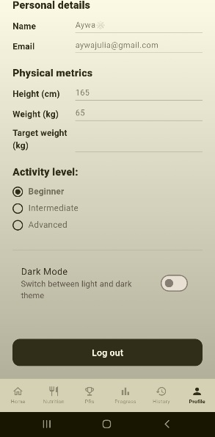
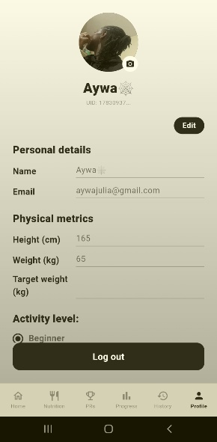after and before updates

- Custom App Icon
Downloaded a custom app icon using the flutter_launch dependency
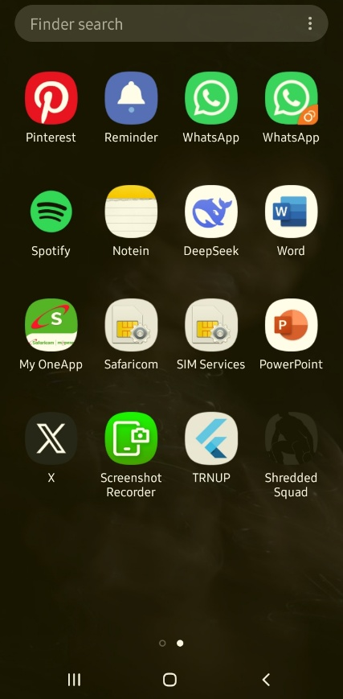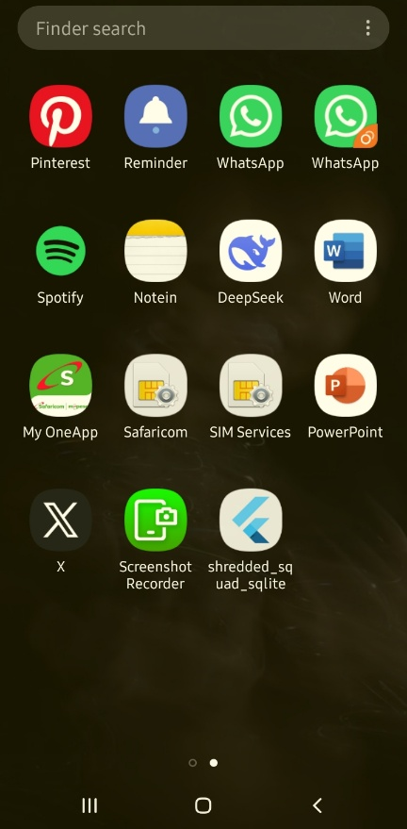before and after icon

- Splash screen
Added an introductory screen displaying App’s name
